**Semester 2 (Unit 3&4) Examination, 2018**

**Question/Answer Booklet**

**MATHEMATICS METHODS**

**Section Two: Calculator-assumed**

Student Name/Number: ______________________________________________

Teacher Name: ______________________________________________

**Time allowed for this section**

Reading time before commencing work: ten minutes

Working time for this section: one hundred minutes

**Materials required/recommended for this section**

**To be provided by the supervisor:** This Question/Answer Booklet

Formula Sheet

**To be provided by the candidate:**

Standard items: pens (blue/black preferred), pencils (including coloured), sharpener,

correction fluid/tape, eraser, ruler, highlighters

Special items: nil

**Important note to candidates**

No other items may be taken into the examination room. It is **your** responsibility to ensure that you do not have any unauthorised notes or other items of a non-personal nature in the examination room. If you have any unauthorised material with you, hand it to the supervisor **before** reading any further.

**Structure of this paper**

|  |  |  |  |  |  |
| --- | --- | --- | --- | --- | --- |
| Section | Number of questions available | Number of questions to be answered | Working time (minutes) | Marks available | Percentage of exam |
| Section One: Calculator-free | 7 | 7 | 50 | 54 | 35 |
| Section Two: Calculator-assumed | 14 | 14 | 100 | 100 | 65 |
|  | | | | | 100 |

**Instructions to candidates**

1. The rules for the conduct of School exams are detailed in the *School/College assessment policy*. Sitting this examination implies that you agree to abide by these rules.
2. Write your answers in this Question/Answer Booklet.

3. You must be careful to confine your responses to the specific questions asked and to follow any instructions that are specific to a particular question.

1. Spare pages are included at the end of this booklet. They can be used for planning your responses and/or as additional space if required to continue an answer.
   * Planning: If you use the spare pages for planning, indicate this clearly at the top of the page.
   * Continuing an answer: If you need to use the space to continue an answer, indicate in the original answer space where the answer is continued, i.e. give the page number. Fill in the number of the question that you are continuing to answer at the top of the page.
2. **Show all working clearly.** Your working should be in sufficient detail to allow your answers to be checked readily and for marks to be awarded for reasoning. Incorrect answers given without supporting reasoning cannot be allocated any marks. For any question or part question worth more than two marks, valid working or justification is required to receive full marks. If you repeat any question, ensure that you cancel the answer you do not wish to have marked.
3. It is recommended that you **do not use pencil**, except in diagrams.
4. The Formula Sheet is **not** to be handed in with your Question/Answer Booklet.

**Section Two: Calculator-assumed (100 Marks)**

This section has **(fourteen)** **14** questions. Answer **all** questions. Write your answers in the spaces provided. Spare pages are included at the end of this booklet.

Suggested working time: **100 minutes**.

**Question 8 (4 marks)**

In 2011, one in 300 Australian adults were doctors. One Australian adult was randomly selected in 2011 and it was noted whether he/she was a doctor. Define *X* as the random variable associated with this trial.

1. Describe the distribution of *X*. (2 marks)
2. State the mean and variance of this distribution. (2 marks)

**Question 9 (9 marks)**

The probability density function of a uniformly distributed random variable *X* is given by 

 



(a) Determine the expected value and variance of *X*. (2 marks)

(b) Determine  (2 marks)

(c) Determine  , the cumulative distribution function of *X*. (3 marks)

(d) Use to determine the upper quartile for this distribution. (2 marks)

**Question 10 (4 marks)**

The population in a certain country is growing continuously at 3% per annum. Its population *P* is such that  where *P* is the population in millions, *t* years from now. The population is currently 35 million.

1. When will the population of the country reach 50 million if it continues to grow at the

same rate? (2 marks)

1. Data suggests that the capital city’s population is growing at a faster rate than that of the country. Currently 22% of the people in the country live in the capital city, and if its population continues to grow at its present rate, 40% of the entire population will live in the capital city 15 years from now. What is the continuous growth rate of the population of the capital city? (2 marks)

**Question 11 (6 marks)**

Show that the exact area of the region bounded by  the *y* axis and the lines  and  is  .

**Question 12 (8 marks) (8 marks)**

The following 95% confidence interval for $p$, the proportion of residents who oppose a new high-rise apartment development, has been obtained based on a random sample of residents:

$$0.53<p<0.61$$

(a) What is $\hat{p},$ the proportion of residents in the sample who oppose the high-rise apartment development? (1 mark)

(b) What is $n$, the sample size? (2 marks)

(c) Another confidence interval for $p$, based on the same sample, is $0.50<p<0.64.$ What is the confidence level of this second interval? (3 marks)

(d) Opponents of the high-rise development claim that this sampling ‘clearly shows that the majority of residents oppose the development’. Is this justified? (2 marks)

**Question 13 (5 marks)**

The velocity of a particle moving along the axis at time  seconds is given by

 where  Initially the particle was 1 metre to the left of the origin.

(a) Initially, is the particle speeding up or slowing down? Justify your answer with calculus.

(3 marks)

(b) Determine the position of the particle after 5 seconds. (2 marks)

**Question 14 (4 marks) (4 marks)**

Infinitely many rectangles which sit on the *x*-axis can be inscribed under the curve .

One such rectangle is shown in the diagram below. Determine the co-ordinates of  such that rectangle  has maximum area.

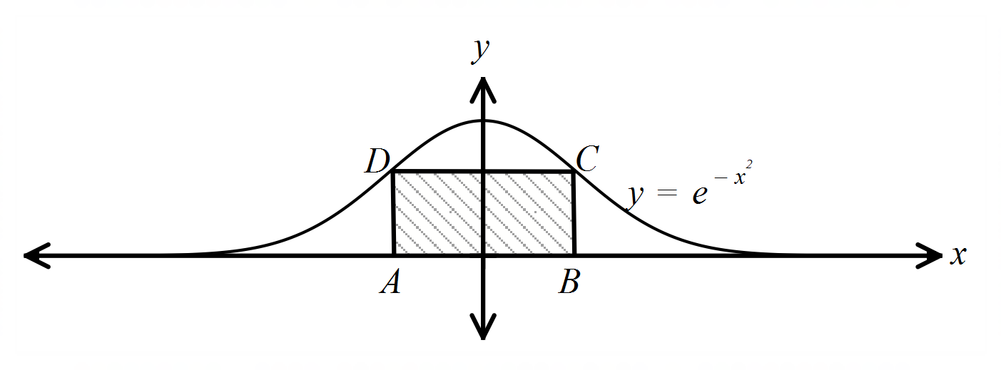

**Question 15 (7 marks)**

A large number of tickets are sold in a lottery. Each ticket can win either a major prize or a small prize but no ticket can win two prizes.

0.1% of tickets win a major prize and 10% of tickets win a small prize.

Luckie has purchased 20 tickets. Let *X* be the number of Luckie’s tickets that win a prize.

(a) If just one ticket is purchased, what is the probability of winning a prize? (1 mark)

(b) State the distribution of *X* and its parameters (2 marks)

(c) Write a formula to determine the probability that Luckie wins no more than 3 prizes.

(2 marks)

(d) Determine the probability that Luckie wins at most three prizes. (1 mark)

(e) If the probability that Luckie wins exactly *k* prizes is 0.1922, determine the value of *k*.

(1 mark)

**Question 16 (10 marks)**

The graph of the function  is shown below for 

The areas, (A), enclosed between the graph, the *x*-axis and the lines  and  are marked in the appropriate regions.

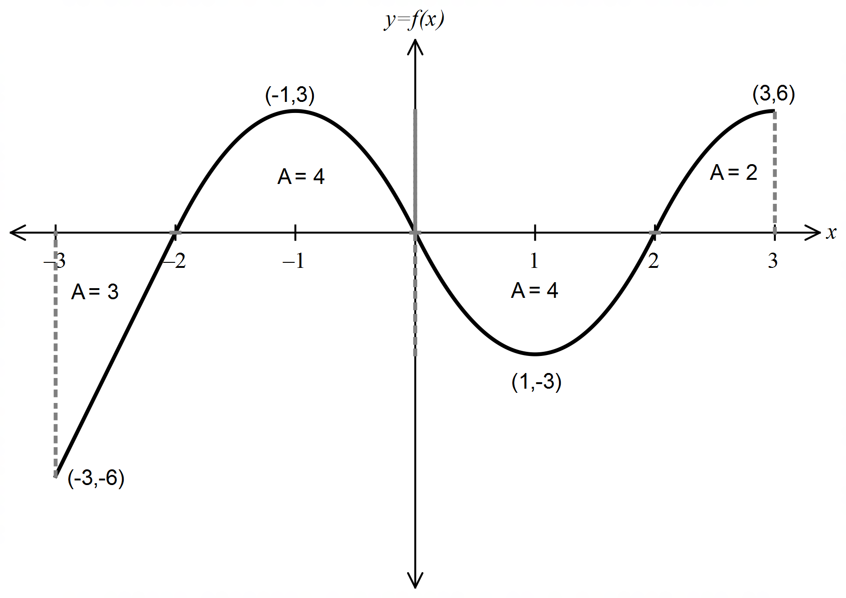

Determine:

(a) (i) the value of  (2 marks)

(ii) the area enclosed between the graph of  and the *x* axis, from  to  (2 marks)

(b)  (3 marks)

The function  is defined by  in the interval 

(c) Determine the maximum value of . Justify your answer.

(3 marks)

**Question 17 (7 marks)**

An orchardist produces peaches and sells them at the markets. Peaches are categorized into sizes - small, medium and large according to the diameter of the individual fruit.

In 2016, the diameters of the crop of peaches were found to be normally distributed with a mean of 65 mm and a standard deviation of 4.9 mm.

The table below shows the classification and expected profit for individual peaches.

|  |  |  |  |
| --- | --- | --- | --- |
|  | small | medium | large |
| Diameter (*d*) of peach,  in millimetres |  |  |  |
| Expected profit per peach | $0.12 | $0.23 | $0.27 |

(a) Complete the table to show the proportion of peaches of each size in the orchardist’s crop in 2016.

|  |  |  |  |
| --- | --- | --- | --- |
|  | small | medium | large |
| Proportion of peaches |  |  | 0.1538 |

(1 mark)

(b) Determine the expected mean and standard deviation of the orchardist’s profit per

peach for 2016. (3 marks)

The peaches are randomly packaged in polystyrene trays of 25 peaches per tray. The cost of each tray is $0.15.

(c) Ignoring any other costs, determine the expected mean and standard deviation of the profit of a tray of peaches. (3 marks)

**Question 18 (5 marks)**

Given the curve $y=xlnx \left(x>0\right)$ use calculus to

1. determine the nature and exact coordinates of the turning point. (4 marks)

1. give a reason why the curve has no point of inflection. (1 mark)

**Question 19 (5 marks)**

The decibel (*dB*) is a logarithmic scale for measuring the intensity or loudness of a sound. The formula that defines the intensity of a sound compared to the intensity of the faintest audible sound is

,

where is the intensity of the sound and  Watts/m2.  represents the intensity of the faintest audible sound.

(a) A restaurant conversation generates a noise of 60 decibels*.* Determine the corresponding intensity in Watts/m2. (2 marks)

Long or repeated exposure to sounds at or above 85 decibels can cause hearing loss. A gunshot from a rifle produces a sound of 85 decibels.

(b) Rearrange the formula above to express  in terms of  for a decibel rating of ,

and hence express the intensity of the gunshot from a rifle in terms of  (2 marks)

1. How much louder is the intensity of the noise from the gunshot of a rifle compared

to a conversation in the restaurant that generates a noise of 60 decibels? (1 mark)

**Question 20 (12 marks)**

The displacement $y(t)$ cm of a mass suspended from a spring at time $t$ seconds is given by

$y\left(t\right)={ae}^{-bt}\sin{ct,}$ for $t≥0$*,*

where $a, b$ and $c$ are positive constants.

(a) Evaluate $a, b$ and $c$, correct to 3 significant figures, given that the mass first returns to its starting position after $9$ seconds, the furthest distance of the mass from its starting position is $60$ cm and this occurs after $4$ seconds. (6 marks)

(b) Show that $y\left(t+\frac{π}{c}\right)=-ry\left(t\right),$ for $t≥0,$ where $r=e^{-bπ/c}.$ (3 marks)

(c) A sketch of the graph of $y(t)$ for $t≥0$ is shown below.

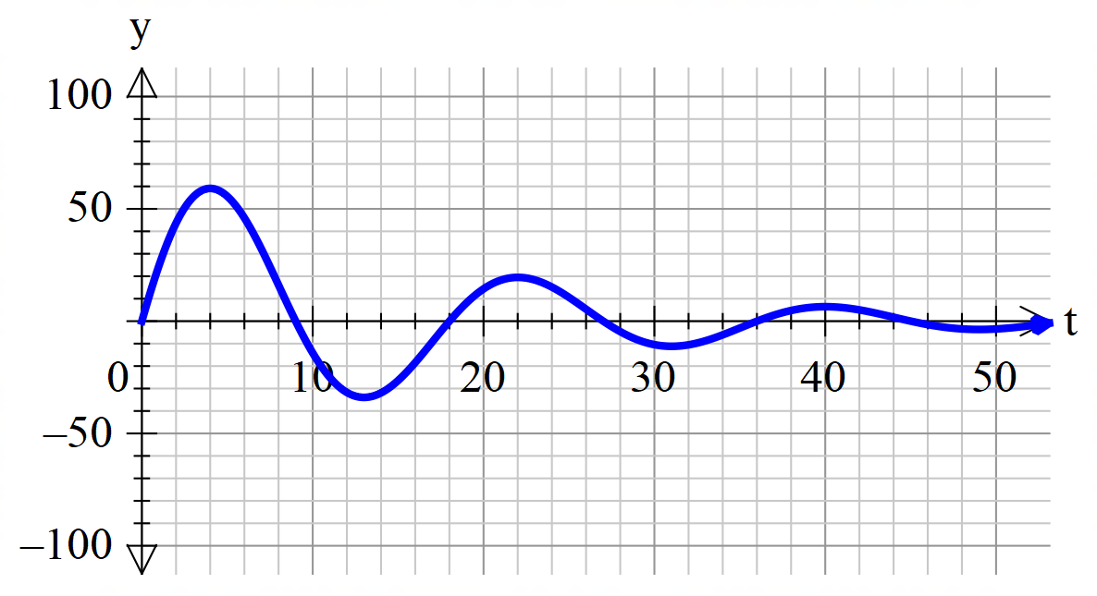

How far does the particle travel between its first and second return to the origin, to the nearest centimetre? (3 marks)

**Question 21 (14 marks)**

A software development company wishes to determine , the proportion of its customers

that are satisfied with the service that the company provides. It plans to do this by surveying

a random sample of its customers.

(a) Calculate a 95% confidence interval for $p,$ given that in a random sample of 700 customers, 465 indicated that they are satisfied with the service provided. (3 marks)

(5 marks)

(b) In a survey conducted 12 months ago it was found that the satisfaction rate of its customers was 65%. Can the company reasonably claim that ‘the new survey clearly shows that satisfaction rates have improved in the past 12 months’? (2 marks)

(c) (i) Consider the confidence interval for a population proportion given by

.

It can be shown that the maximum value of  is 0.25.

Use the above information to show that the maximum value of the Margin of

error,  for a confidence interval of 95% is less than .

(3 marks)

(ii) A statistician proposed a different, simple confidence interval for a population proportion, given by

$$\hat{p}-\frac{1}{\sqrt{n}}<p<\hat{p}+\frac{1}{\sqrt{n}}$$

State the Margin of error, in terms of  for this simplified interval. (1 mark)

(iii) Use your answers from parts (i) and (ii) above to explain why the confidence

level for the simplified confidence interval is at least 95%. (1 mark)

(d) Determine the true level of confidence of the simplified interval if $\hat{p}=0.7$ (3 marks)

(e) If the software company had chosen to use this simplified confidence interval, would their sample size of 700 be appropriate if they required the margin of error to be at most 0.04 and the confidence level to be at least 95%? Justify your answer.

(1 mark)

Additional working space

Question number: __________________

© MAWA, 2018

This examination is Copyright but may be freely used within the school that purchases this licence.

* The items that are contained in this examination are to be used solely in the school for which they are purchased.
* They are not to be shared in any manner with a school which has not purchased their own licence.
* The items and the solutions/marking keys are to be kept confidentially and not copied or made available to anyone who is not a teacher at the school. Teachers may give feedback to students in the form of showing them how the work is marked but students are not to retain a copy of the paper or the marking guide until the agreed release date stipulated in the purchasing agreement/licence.

*Published by The Mathematical Association of WA*

*12 Cobbler Place, MIRRABOOKA 6061*